Simplified Refuge Stage Model
Version 1.10

This modeling effort evolved from a water and constituent mass model developed by Dr. Bill Walker (2004). At present model is based on a simplified water budget for the Arthur R. Marshall Loxahatchee National Wildlife Refuge. This model projects canal and marsh stage from observed inflow, outflow, precipitation, and evapotranspiration. The objective of this model is to provide a useful tool in support of Refuge water management decisions. At this time the model is implemented as an Excel workbook titled “WaterBudget.xls.” This report documents model theory, structure, and implementation. Information on model calibration and verification are briefly presented, and will be fully documented elsewhere. A simple constituent mass and concentration model is also under development and will be documented elsewhere.

This report is in three sections. Section 1 describes the model conceptualization and provides the theoretical background used in this model. Section 2 provides a limited discussion of model calibration and provides information needed to support model applications. Section 2 describes the details of the implementation of the model as an Excel workbook.

SECTION 1: Model theory and structure

The simplified Refuge water budget model divides the Refuge into two connected compartments or boxes (Figure 1). The model integrates net inflow minus outflow for each compartment to provide a daily estimate of stage and volume within each compartment. The user provides a daily time-series of pumped inflow, precipitation, evapotranspiration, and optionally provides total structure outflow. The model calculates flow between the canal and marsh, and groundwater recharge including levee seepage loss. Optionally, the model can calculate total structure outflow based on a simple model of historic gate operations under the current Refuge regulation schedule (Neidrauer 2004; USACE 1994; USFWS 2000).

Canal
Marsh
Q_{E}
Q_{MI}
P
P
ET
ET
G
G
Q_{RO}

Figure 1. Refuge water budget model structure is composed of 2 compartments (boxes) representing the canal and marsh. Inflows (red) and outflows (blue) are drawn as arrows pointing in the positive flow direction. Inflows include precipitation (P), pumped inflow (Q_{E}), and flow from canal to marsh (Q_{MI}). Outflows include evapotranspiration (ET), groundwater recharge (G), and structure flows (Q_{RO}). Figure copied from (Meselhe et al. 2006).

Water budget equations:

Discharge between canal and marsh (into marsh is positive) is based on the “power law model” (Kadlec and Knight 1996, page 203)

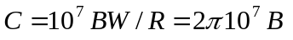

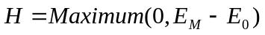

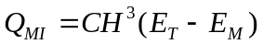

Tailwater and marsh stage

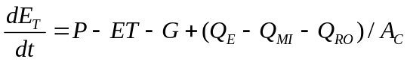

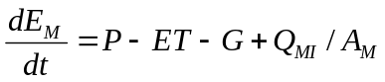
where
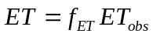
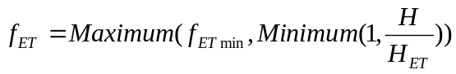

Nomenclature:

Constants and initial estimates

B 7 m⁻¹d⁻¹, Transport coefficient (1 to 5)
W 8.15 10⁴ m, Average marsh perimeter
R 1.30 10⁴ m, Average radius of marsh (~Circular Geometry)
C 44.0 10⁷ m⁻¹d⁻¹, B 10⁷ W/R = 2π B 10⁷
E₀ 4.57 m, 15 ft, marsh ground elevation
A_{C} 5.5 10⁶ m² (100 km long, 55 m wide), Area of the canals
A 5.29 10⁸ m², Marsh Area - assume 90% of Refuge
r_{seep} 0.0004 d⁻¹, Seepage rate constant
E_{B} 3.5 m, Boundary water surface elevation
H_{ET} 0.25 m, depth above which ET is not reduced
F_{ETmin} 20%, minimum reduction of ET because of shallow depth

Input time series

P m/d, Precipitation
ET_{obs} m/d, Marsh Evapotranspiration Rate (STA1W Data)
Q_{E} m³/d, External Inflows to Rim Canal
Q_{RO} m³/d, Outflows from Rim Canal

Calculated time series

H m, Marsh water depth
Q_{MI} m³/d, flow from canal to marsh
E_{T} m, Canal water surface elevation
E_{M} m, Marsh water surface elevation
G_{i} m/d, Rate of loss of groundwater recharge in canal or marsh
F_{ET} dimensionless, reduction of observed ET at low depths

Computational methods

The differential equations for canal and marsh stage are calculated using the Euler numerical integration method with a one-day time step. This provides a fast solution and is easily implemented using the available daily average time-series data. However, one problem with this technique is that when net canal flow is large, stage change over one day is so large that the assumption of “small” change in the integration algorithm is not satisfied. This can result in failure of convergence and instability. Here, a heuristic approach is used to stabilize the solution that is otherwise unstable at times. This heuristic approach limits the magnitude of the canal stage, and maintains conservation of water volume by shifting flow directly to the marsh. Such an approach is reasonable because under these conditions flow between the marsh and canal is likely being underestimated by the Eulerian method with a daily time-step. Denoting the revised stage derivative with an asterisk, this heuristic scheme is

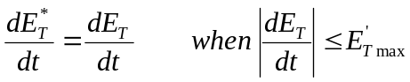
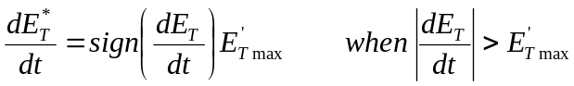

The additional flow into the marsh, Q_{MI}*, is
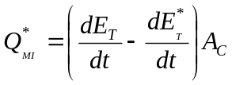
and

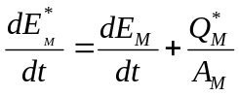

Literature cited:

SECTION 2. Model calibration

The information in this section is based on a presentation at the 2006 EWRI meeting (Meselhe et al. 2006). The SRSM water budget model was calibrated using the period from 1995 to 1999, and validated with the data from 2000 to 2004. The major calibration parameter is the transport coefficient (B) in Eq. 5, and it was found that a value equal to 30 m⁻¹d⁻¹ produced the best agreement between observed and predicted values. Figure 2 shows the comparison between the calculated and the observed canal stages for the calibration and validation periods, and Figure 3 shows the same information for the marsh stages. As can been seen in these Figures observed and predicted values are in good agreement.

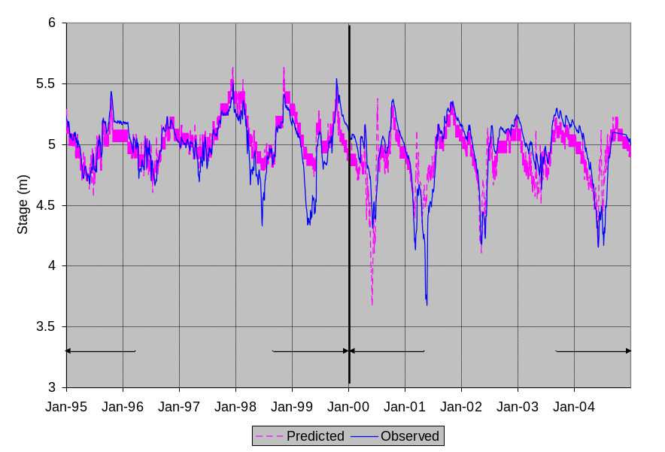

Figure 2. Observed vs. Predicted Canal Stages for the Calibration and Validation Periods.

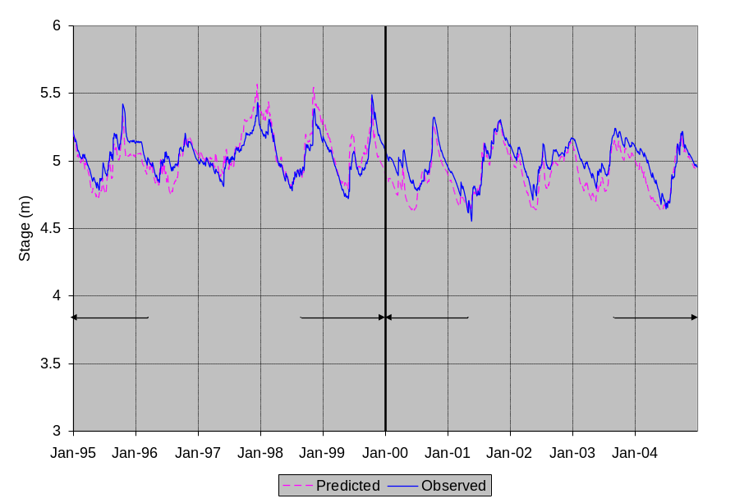

Figure 3. Observed vs. Predicted Marsh Stages for the Calibration and Validation Periods.

Statistical analyses were performed for the calibration and validation periods. The statistics included bias, root mean square error (RMSE), correlation coefficient (R), the variance reduction and the Nash Sutcliffe efficiency (Nash and Sutcliffe 1970). These statistical parameters are shown in Table 1. As can be seen in this Table, the observed and predicted stages for the marsh are in better agreement than the observed and predicted values for the canal. There are probably three reasons for that: (1) the area for the rim canal was assumed constant, (2) the variability of the water level is stronger in the canal than in the marsh, and (3) the emphasis during the calibration was to match the observed marsh stages with the model prediction.

Table 1. Statistical parameters for the SRSM double box water budget model.

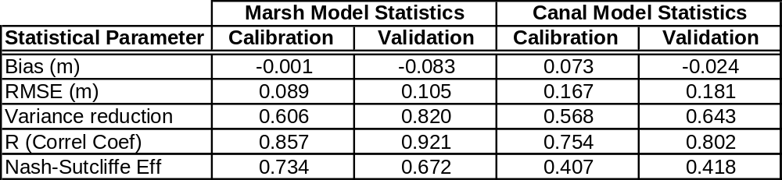

Table 2. Constants currently used in the calibrated SRSM double box model.

B | 30 | m⁻¹d⁻¹, Transport coefficient (1 to 5), Kadlec & Knight (1996)
W | 81,500 | m, Average marsh perimeter
Radius | 13,000 | m, Average radius of marsh (~Circular Geometry)
Const | 1.88E+09 | m/d, B 10⁷ W/R = 2π B 10⁷
E₀ | 4.57 | m, 15 ft, marsh ground elevation
A_{C} | 4.03E+06 | m² Area of Canal Calculated from Chainage and Depths
Am | 5.60E+08 | m², Marsh Area
rseep | 0.000004 | 1/d, seepage loss rate constant
lseep | 0.06 | 1/d, seepage loss rate constant for the levee
EB | 3.5 | m, boundary stage
dt | 1 | Day
MinH | 0 | m, minimum H used in calculation
MaxdETdt | 0.1 | m, maximum daily change in canal stage
HET | 0.25 | m, depth when ET is maximum
ETMin | 20% | dimensionless, minimum ET reduction factor
Date0 | 1/1/1995 | Start date
ET0 | 5.24 | m, initial canal stage
EM0 | 5.23 | m, initial marsh stage
InPct | 100% | Multiplies inflow to reduce/enlarge historic flow
OutPct | 100% | Multiplies outflow to reduce/enlarge historic flow
Position0 | 75% | Regulation schedule position for zero outflow
A1FloorQ | 2.50E+06 | m3/d, Refuge outflow when stage is at A1 floor
Q18-A1Floor= | 2.00E+07 | m3/d, Refuge outflow at 5.4864 m (18 ft) minus A1FloorQ
CalcQRO | TRUE | Use Calculated (T) or Historic (F) outflows in simulation

SECTION 3. Model implementation

The SRSM is implemented as an Excel workbook, water_budget.xls. This workbook calculates a water budget for the Refuge canals and marsh using data and mass balance equations. The distributed model version does not contain the observed calibration or verification data or statistics, and is intended for scenario analysis, rather than calibration.Worksheets in the model workbook include:
ReadMe - This informational sheet provides basic information concerning the model and model version.

Constants - Values of model constants are set on this sheet. For scenario analysis, few if any of these constants should be adjusted.

RegSched - The Refuge regulation schedule is defined here as stage levels by Julian date. Analysis of alternative regulation schedules would likely require modification of this sheet.

TimeSeries - Time series data used by the model are defined here. The input daily-value time series are in columns, with data values in rows. Columns are
Date – date for the row’s values
Month/Year – the month and year of the data
Day – day of the month

P – precipitation (m/d)
ET – evapotranspiration (m/d)
QE – flow into the Refuge (m³/d)
Historic QRO – historic data for flow out of Refuge (m³/d)
Calc QRO (m³/d) – Flow out of the Refuge based on the regulation schedule. Note that this flow does not include water supply or other non-regulatory outflows.
QRO (m³/d) – model selected outflow based on the constant calcQRO
%iQE-%0QRO (m³/d) – Net flow (in-out) of the Refuge adjusted by two percentages, InPct and OutPct. This is the flow that is used in the water budget calculations.

Year – the calendar year
FedWYear – the federal water year, October 1 to September 30
FlWYear – the Florida water year, May 1 to April 30

Model - Calculations of model stages are performed here

DOY-YR-Marsh - Pivot Table of daily marsh stage with each calendar year in a column

Charts
GERefPlot - Plot of number of days marsh stage exceeds a reference elevation

PctPlot - Plot of percentiles of marsh stage

For more information contact
Dr. Ehab Meselhe (meselhe@louisiana.edu),
Mike Waldon (mike@mwaldon.com), or
Jeanne Arceneaux (jca1666@louisiana.edu )

